Swasthya Mitra : Smart Helthcare Mangement Platform

A Project Report
In the partial fulfillment of the award of the degree of

BCA
Submitted by
Prithwijit Khan
Ayan Koley


Techno College Hooghly

Certificate from the Mentor

This is to certify that Prithwijit Khan, Ayan Koley has completed the project titled Swasthya Mitra web design by Figma under my supervision during the period from [July 2026] to [August 2026] which is in partial fulfillment of requirements for the award of the B.TECH/MCA/BCA and submitted to Department Bachelor of Computer Application of Techno College Hooghly.

Signature of the Mentor

Date:

Acknowledgment

I take this opportunity to express my deep gratitude and sincerest thanks to my project mentor, Subhajit Santra for giving the most valuable suggestions, helpful guidance, and encouragement in the execution of this project work.

ABSTRACT

The increasing demand for accessible, efficient, and digitally connected healthcare services has highlighted the limitations of traditional healthcare systems, which often involve time-consuming doctor searches, complicated appointment procedures, limited access to healthcare information, and inefficient communication between patients and healthcare professionals. This project, titled “Swasthya Mitra: Smart Healthcare Management Platform,” aims to provide an interactive and user-friendly web-based healthcare interface that connects patients with qualified doctors and healthcare services in a streamlined and convenient manner.
The primary objective of this project is to digitize and simplify the healthcare experience by enabling users to search for doctors based on specialization, location, availability, ratings, and consultation fees. The platform also allows patients to view detailed doctor profiles, book appointments, manage consultations, and access relevant healthcare information through a centralized dashboard. The UI/UX design is developed using Figma, ensuring scalability, consistency, accessibility, and a responsive user interface across different devices.
The methodology adopted follows a modular and user-centered design approach based on the Iterative Waterfall Model, where user research, requirement analysis, information architecture, wireframing, prototyping, visual design, usability testing, and developer handoff are carried out through structured phases. A consistent design system, reusable UI components, intuitive navigation, and accessible design principles are implemented to improve usability and provide a seamless user experience.
The results demonstrate that the proposed design reduces the effort required to find suitable healthcare professionals, simplifies the appointment-booking process, and improves access to healthcare services through organized search and filtering features. The platform successfully bridges the gap between patients and healthcare providers by offering a centralized, reliable, and visually engaging digital healthcare solution.
In conclusion, the proposed UI/UX design provides an efficient, scalable, and user-friendly solution for modern healthcare challenges. The platform has the potential for future enhancements, including AI-based doctor recommendations, online video consultations, digital health records, medicine reminders, and real-time healthcare assistance.

CONTENT PAGE
CONTENTS | Page No.
1. Introduction | 1
1.1 Project Overview | 2
1.2 Problem Statement | 3
1.3 Objectives | 4
1.4 Scope of the Project | 5
1.5 Methodology | 6
2. Literature Review | 7
2.1 Existing Systems | 8
2.2 Limitations of Existing Systems | 9
2.3 Comparison with Proposed System | 10
2.4 Conclusion of Literature Review | 12
3. System Analysis | 13
3.1 Requirement Analysis | 14
3.2 Feasibility Study | 16
4. System Design | 18
4.1 Architecture Diagram | 20
4.2 Design System Table | 21
4.3 Use Case Diagram | 22
5. Technology Stack | 23
6. Implementation | 25
6.1 Module Description | 25
6.2 UI Screens / Implementation Screenshots | 28
7. Testing | 51
7.1 Test Cases | 52
7.2 Unit Testing | 54
7.3 Integration Testing | 54
7.4 Functional Testing | 55
7.5 User Interface Testing | 56
7.6 Performance Testing | 57
7.7 Testing Summary | 57
8. Results & Discussion | 58
8.1 Output Screenshots | 58
8.2 Performance Analysis | 60
8.3 Observations | 61
8.4 Conclusion of Results | 62
9. Conclusion | 63
9.1 Achievements | 64
9.2 Summary of the System | 64
9.3 Overall Outcome | 65
9.4 Final Statement | 65
10. Future Scope | 66
10.1 Improvements | 66
10.2 AI Integration | 68
10.3 Mobile Application Version | 69
10.4 Cloud & Deployment Enhancements | 70
10.5 Future Expansion | 71
References | 72

INTRODUCTION

In today’s rapidly evolving healthcare sector, traditional methods of finding doctors and booking medical appointments are often time-consuming, inconvenient, and difficult to manage. Patients may face challenges such as limited access to reliable doctor information, difficulty comparing healthcare professionals, long waiting times, and complicated appointment procedures. To address these challenges, Swasthya Mitra: Smart Healthcare Management Platform is a UI/UX design project that aims to simplify and improve access to healthcare services through intuitive interfaces, organized information, and user-centered design.
The platform is conceptualized and designed using Figma and enables users to search for healthcare professionals based on specialization, location, availability, consultation fees, and ratings. Users can explore detailed doctor profiles, view professional information, select suitable appointment slots, and manage their healthcare activities through a centralized and easy-to-use dashboard. The design focuses on improving usability, accessibility, and user engagement by presenting healthcare information in a clear, structured, and visually organized manner.
The platform also provides healthcare professionals with a clean and efficient interface to present their qualifications, experience, areas of specialization, consultation details, and availability. By using consistent layouts, reusable design components, simple navigation, and interactive prototypes, the system ensures a seamless experience for both patients and healthcare providers.
By introducing thoughtful UI/UX design and interactive prototyping, Swasthya Mitra minimizes user effort, improves the process of discovering suitable healthcare professionals, and simplifies appointment management. The project aims to bridge the gap between patients and healthcare services by providing a centralized, accessible, and user-friendly digital healthcare experience.

2A. Project Overview

Swasthya Mitra: Smart Healthcare Management Platform is a UI/UX design project created to simplify and modernize access to healthcare services for both patients and healthcare professionals. The design provides a centralized platform concept where users can search for doctors, explore healthcare services, view detailed doctor profiles, and book appointments efficiently.
This project has been developed to overcome the limitations of traditional healthcare systems, which are often time-consuming, fragmented, and difficult to access. Patients may face challenges in finding suitable doctors, comparing healthcare professionals, checking availability, and managing appointments. By leveraging modern UI/UX design principles and interactive prototyping in Figma, the system concept ensures a clean, intuitive, accessible, and user-friendly healthcare experience.
The primary purpose of designing this platform is to improve the process of finding healthcare professionals, reduce user effort, and make healthcare information more organized and accessible. It enables patients to search for doctors based on specialization, location, availability, consultation fees, and ratings while allowing healthcare professionals to present their qualifications, experience, services, and appointment availability effectively.
Through structured layouts, simple navigation, reusable design components, and interactive prototypes, Swasthya Mitra aims to create a seamless connection between patients and healthcare providers. The platform promotes a more convenient, efficient, and digitally connected healthcare experience while ensuring that users can access essential healthcare services through a centralized and visually engaging interface.

2B. Problem Statement

In the current healthcare sector, traditional healthcare management systems face several challenges, including time-consuming appointment processes, fragmented healthcare information, limited access to reliable doctor details, and difficulties in connecting patients with suitable healthcare professionals.
Patients often need to search through multiple websites or visit healthcare facilities to find appropriate doctors, check their availability, compare consultation details, and book appointments. This process may result in confusion, unnecessary delays, and difficulty in accessing relevant healthcare services. On the other hand, healthcare professionals may face challenges in presenting their qualifications, areas of specialization, experience, consultation details, and available appointment slots in a clear and organized manner.
Additionally, many existing healthcare platforms lack intuitive navigation, effective search and filtering options, organized healthcare information, and user-friendly appointment management features. Therefore, there is a need for a well-designed Smart Healthcare Management Platform that can improve accessibility, simplify doctor discovery, streamline appointment booking, and provide a convenient digital healthcare experience for both patients and healthcare professionals.

2C. Objectives

The main objectives of the Swasthya Mitra: Smart Healthcare Management Platform UI/UX design are as follows:
- To design a user-friendly and responsive interface for seamless navigation and easy access to healthcare services
- To create clear and organized layouts for presenting doctor profiles, healthcare information, specializations, and consultation details
- To simplify the doctor discovery process through intuitive search, filtering, and well-structured information
- To improve the appointment booking experience by providing clear doctor availability, appointment slots, and easy scheduling options
- To enhance user engagement through consistent design elements, visual hierarchy, interactive prototypes, and user-centered interfaces
- To ensure accessibility, readability, and usability across different user groups and devices
- To provide a structured design framework for searching healthcare professionals based on specialization, location, availability, consultation fees, and ratings
- To improve communication and interaction between patients and healthcare professionals through well-designed information flows
- To reduce the time and effort required to find suitable doctors and access healthcare services
- To maintain design consistency, accessibility, and usability throughout the platform using reusable components and a unified design system.

2D. Scope of the Project

The scope of this project includes the UI/UX design of the Swasthya Mitra: Smart Healthcare Management Platform, which is a digital healthcare platform concept designed to support patients, healthcare professionals, and administrators.
Patients are considered in the design through user-friendly interfaces that allow them to search for doctors, explore healthcare services, view detailed doctor profiles, check availability, and book appointments. The platform also provides organized access to important information such as doctor specialization, qualifications, experience, consultation fees, ratings, and available appointment slots.
Healthcare professionals are addressed through structured interface designs that allow them to present their professional details, areas of specialization, experience, consultation information, and availability in a clear and organized manner. Administrators may use the platform concept to manage doctor information, patient records, appointments, healthcare services, and overall platform activities.
The design concept can be applied to various healthcare sectors, such as hospitals, clinics, diagnostic centers, private healthcare organizations, and online healthcare service providers. The interactive prototypes are created using Figma and are designed to provide a responsive and consistent experience across both mobile and desktop devices.
Future design enhancements may include online video consultations, digital health records, AI-based doctor recommendations, medicine reminders, secure online payments, real-time appointment notifications, emergency healthcare support, and patient feedback interfaces.

2E. Methodology

The methodology includes the following steps:
- User Research: Understanding the needs, expectations, and challenges faced by patients while searching for doctors, accessing healthcare information, and booking appointments. The requirements of healthcare professionals are also considered to create an efficient and user-friendly healthcare platform.
- Information Architecture: Organizing healthcare content, user flows, navigation, and platform features to ensure easy access to doctor profiles, specializations, appointment details, healthcare services, and other relevant information.
- Wireframing: Creating low-fidelity layouts to define the structure of the platform, content placement, navigation patterns, and key user interactions before developing the final visual design.
- Visual Design: Developing high-fidelity user interfaces in Figma using a consistent color palette, typography, icons, visual hierarchy, and reusable UI components that reflect a professional, trustworthy, and accessible healthcare environment.
- Prototyping: Building interactive prototypes in Figma to simulate important user journeys, including doctor search, doctor profile exploration, appointment booking, and healthcare service navigation across mobile and desktop screens.
- Usability Testing: Conducting feedback sessions to evaluate the clarity, accessibility, ease of navigation, readability, and overall user experience of the healthcare platform.
- Iteration: Refining the designs based on user feedback and testing insights to improve navigation, search and filtering features, visual hierarchy, accessibility, and the overall healthcare experience.
This structured methodology ensures that Swasthya Mitra: Smart Healthcare Management Platform is designed efficiently through proper research, planning, prototyping, testing, and continuous refinement. The approach helps create a clear, accessible, user-centered, and visually consistent healthcare platform for patients and healthcare professionals.

---

LITERATURE REVIEW

The literature review provides an understanding of existing digital healthcare platforms, their design models, limitations, and the need for an improved healthcare management system. In the field of digital healthcare, many web-based and mobile healthcare platforms have been developed to connect patients with doctors, hospitals, and other healthcare services. These systems have significantly reduced dependence on traditional healthcare processes and contributed to the digital transformation of the healthcare industry.
Several existing healthcare platforms provide essential services such as doctor discovery, online appointment booking, consultation services, healthcare information, patient reviews, and access to medical specialists. These platforms have improved the accessibility and convenience of healthcare services by allowing users to search for healthcare professionals and access relevant information through digital interfaces.
However, many existing healthcare platforms may contain complex navigation, overloaded information, unclear appointment flows, or limited personalization. The proposed Swasthya Mitra: Smart Healthcare Management Platform is designed to address these challenges by providing a more organized, user-friendly, accessible, and visually engaging healthcare experience through thoughtful UI/UX design.
The platform focuses on helping users find suitable doctors based on key factors such as specialization, location, availability, consultation fees, and patient ratings. It also provides structured doctor profiles, clear healthcare information, simple appointment booking, and intuitive navigation. By applying user-centered design principles, consistent visual elements, reusable components, and interactive prototypes, Swasthya Mitra aims to reduce user effort and improve the overall experience of accessing healthcare services.

3A. Existing Systems

Existing online healthcare platforms are web-based and mobile-based systems that allow patients to search for doctors, view healthcare information, book appointments, and access various medical services. These systems have reduced dependence on traditional healthcare methods such as visiting hospitals or clinics to obtain doctor information, booking appointments manually, and maintaining paper-based medical records.
Popular healthcare platforms generally provide the following common features:
- Doctor search based on name, specialization, or location
- Doctor profiles containing qualifications, experience, and consultation details
- Online appointment booking and appointment management
- Patient ratings and reviews
- Online consultation and healthcare information services
- Hospital and clinic search facilities
Although these systems have improved access to healthcare services, many of them contain large amounts of information, complex navigation, and multiple services within a single interface. This can make it difficult for users to quickly find suitable doctors, understand healthcare information, or complete the appointment-booking process efficiently.
Additionally, existing healthcare platforms often combine many services, such as doctor consultations, medicine delivery, diagnostic tests, health insurance, and medical information. While these features provide a wide range of services, they may create cluttered interfaces and make navigation overwhelming, especially for users who primarily want to search for a doctor and book an appointment.
These limitations highlight the need for a simplified Smart Healthcare Management Platform design that focuses on essential healthcare services, including doctor discovery, specialization-based search, detailed doctor profiles, appointment booking, and healthcare information, in a clear, user-friendly, accessible, and visually engaging manner.

---

3B. Limitations of Existing Systems

Despite their popularity and usefulness, existing healthcare platforms have several limitations that may affect their efficiency, accessibility, and overall user experience.
The major limitations are as follows:
- Information Overload: Many healthcare platforms display a large number of services, such as doctor consultations, medicine delivery, diagnostic tests, health insurance, medical articles, and wellness programs. This can make it difficult for users to focus on their primary healthcare needs.
- Complex Navigation: Users may need to browse through multiple menus, pages, and service sections to find suitable doctors, view relevant healthcare information, or book appointments. This process can be time-consuming and confusing.
- Difficulty in Finding Suitable Doctors: Patients may receive a large number of doctor listings without clear prioritization based on specialization, location, availability, consultation fees, or ratings. This can make doctor selection difficult.
- Unorganized Information Presentation: Important details such as doctor qualifications, experience, areas of specialization, consultation fees, and available appointment slots may not always be presented clearly or consistently.
- Limited Personalization: Some existing systems provide generalized doctor recommendations and may not effectively match patients with healthcare professionals based on their specific requirements and preferences.
- Complicated Appointment Booking: The appointment-booking process may involve multiple steps, unclear availability information, or complex forms, which can increase user effort and reduce convenience.
Cluttered User Interfaces: The inclusion of many healthcare services and promotional content can create crowded layouts, making it difficult for users to quickly access essential features.
Accessibility Challenges: Some platforms may have small text, unclear visual hierarchy, inconsistent layouts, or limited accessibility features, which can make the interface difficult to use for different user groups.
These limitations demonstrate the need for a simplified and focused healthcare management platform, such as Swasthya Mitra: Smart Healthcare Management Platform, which provides essential services including doctor discovery, specialization-based search, organized doctor profiles, clear appointment availability, and simple appointment booking through a clean, accessible, user-friendly, and visually organized interface.

3C. Comparison with the Proposed System

The proposed Swasthya Mitra: Smart Healthcare Management Platform offers several improvements over traditional healthcare management methods and existing digital healthcare platforms. It is designed to provide a more organized, accessible, efficient, and user-friendly healthcare experience for patients and healthcare professionals.
The comparison is as follows:

System Type | Features | Advantages | Limitations
Traditional Healthcare System | Hospital visits, manual appointment booking, paper-based records, and offline doctor information | Familiar process and direct interaction with healthcare staff | Time-consuming, requires physical visits, limited accessibility, and difficult appointment management
Existing Online Healthcare Platforms | Doctor search, online consultations, appointment booking, medicine delivery, diagnostic services, and healthcare information | Easy access to healthcare services and a wide range of medical facilities | Complex navigation, information overload, cluttered interfaces, and multiple services may make doctor discovery difficult
Proposed Swasthya Mitra: Smart Healthcare Management Platform | Doctor search based on specialization, location, availability, consultation fees, and ratings; organized doctor profiles; simple appointment booking; clean layouts; responsive prototypes in Figma | Faster doctor discovery, reduced user effort, improved clarity, easy appointment management, and enhanced user experience | Currently focused on core healthcare services; additional features can be included in future designs

The proposed system provides a more structured and user-centered approach to accessing healthcare services. It reduces the effort required to find suitable doctors, improves the organization and presentation of healthcare information, and simplifies the appointment-booking process through a clean, intuitive, and visually engaging interface.
The platform focuses on essential healthcare functions, including doctor discovery, specialization-based filtering, detailed doctor profiles, appointment scheduling, and healthcare information, while maintaining consistency, accessibility, and usability throughout the design. Future enhancements may include online video consultations, digital health records, AI-based doctor recommendations, medicine reminders, secure online payments, and real-time appointment notifications.

3D. Conclusion of Literature Review
The study of existing healthcare platforms shows that digital systems have improved access to doctors, healthcare information, and appointment services. However, many platforms still face issues such as complex navigation, information overload, and complicated appointment processes.
The proposed Swasthya Mitra: Smart Healthcare Management Platform addresses these challenges through a clean, organized, and user-friendly UI/UX design. By focusing on doctor discovery, detailed doctor profiles, specialization-based search, and easy appointment booking, the platform reduces user effort and improves accessibility.
Therefore, this project demonstrates how user-centered UI/UX design can improve clarity, usability, and the overall digital healthcare experience.

SYSTEM ANALYSIS

System Analysis is an important phase in UI/UX design that involves understanding user requirements, identifying healthcare-related needs, and evaluating the feasibility of the proposed platform. This phase ensures that the developed design meets user expectations and provides an efficient, accessible, and user-friendly healthcare experience.
In the context of Swasthya Mitra: Smart Healthcare Management Platform, System Analysis helps identify patient needs, healthcare service requirements, user behavior, and interface expectations. It ensures that the platform provides easy doctor discovery, organized healthcare information, clear navigation, detailed doctor profiles, and a simple appointment-booking experience.
The analysis focuses on creating a structured and user-centered platform that helps patients find suitable doctors based on specialization, location, availability, consultation fees, and ratings, while providing healthcare professionals with an organized way to present their professional information and services.

4A. Requirement Analysis

Requirement Analysis defines the functionalities and design expectations of the system. It is divided into Functional Requirements and Non-Functional Requirements.

Functional Requirements
Functional requirements describe the core features and operations of the Swasthya Mitra: Smart Healthcare Management Platform design.
The main functional requirements are as follows:
- Doctor Search: The system must allow users to search for doctors based on name, specialization, or location.
- Doctor Filtering: Users should be able to filter doctors based on specialization, location, availability, consultation fees, and ratings.
- Doctor Profile Display: Users should be able to view detailed doctor profiles containing qualifications, experience, specialization, consultation fees, ratings, and availability.
- Appointment Booking: Users should be able to select a suitable date and time slot and book appointments with healthcare professionals.
- Healthcare Information: The system should provide clear and organized information about healthcare services and medical specializations.
- Content Organization: Healthcare information must be presented using clear headings, icons, structured layouts, and consistent design elements to avoid confusion and information overload.
- Responsive Layouts: The design must adapt to both mobile and desktop screen sizes to ensure accessibility and ease of use.
- Interactive Prototyping: Important user flows, such as Home → Doctor Search → Doctor Profile → Appointment Booking, must be demonstrated through clickable Figma prototypes.

Non-Functional Requirements

Non-functional requirements define the quality, usability, and design attributes of the Swasthya Mitra: Smart Healthcare Management Platform. The main non-functional requirements are:
- Usability: The interface should be user-friendly, intuitive, and easy to navigate for patients, healthcare professionals, and users of different age groups.
- Visual Consistency: The design must maintain consistent colors, typography, icons, buttons, spacing, and layouts across all screens.
- Responsiveness: The layout should adapt smoothly to both mobile and desktop screen sizes to ensure easy access and usability.
- Performance: The Figma prototype should load quickly, and transitions between screens should be smooth during user interaction and testing.
- Aesthetics: The design should create a professional, clean, trustworthy, and visually appealing healthcare experience using balanced layouts and appropriate visual elements.
- Accessibility: Text contrast, font sizes, icons, buttons, and interactive elements must be designed to ensure clear readability and easy interaction for different users.
- Security and Privacy: The design should consider the secure handling of patient information and maintain privacy when displaying healthcare-related data.
- Scalability of Design: The design system should be structured so that additional healthcare services, doctors, specializations, and features can be added in the future without redesigning the entire platform.

4B. Feasibility Study
The proposed Swasthya Mitra: Smart Healthcare Management Platform is technically feasible as it uses modern and widely adopted design tools such as Figma for creating the UI/UX design and interactive prototype.
These tools provide:
- High design efficiency and ease of use
- Easy prototyping and screen linking
- Reusable components and design systems
- Strong community support and plugin ecosystem
- Real-time collaboration and cloud-based access
The platform can be designed using standard resources such as Figma, free icon libraries, healthcare-related visual assets, and open-source images, making the design and prototyping process straightforward and efficient.

Economic Feasibility
The proposed system is economically feasible as it requires minimal cost for design, prototyping, and presentation.
- Figma provides free plans suitable for academic projects
- The design can be created using free tools and design assets
- No hosting or server costs are required for the prototype
- No development or maintenance costs are involved since the project is currently a UI/UX design concept
Thus, the overall cost of designing and presenting the Swasthya Mitra: Smart Healthcare Management Platform is minimal, affordable, and suitable for an academic project.

Operational Feasibility
The proposed Swasthya Mitra: Smart Healthcare Management Platform is operationally feasible as it is designed to be simple, intuitive, and easy to use for patients and healthcare professionals.
- Easy to Understand: The platform provides clear navigation and organized healthcare information, requiring no prior technical knowledge.
- Minimal User Effort: Users can search for doctors, view doctor profiles, and book appointments through simple and well-structured user flows.
- Simple Healthcare Access: Important information such as doctor specialization, experience, consultation fees, ratings, and availability is presented clearly for easy decision-making.
- No Backend Dependency: As the project is a UI/UX design prototype, it operates without requiring a backend system, database, server setup, or complex maintenance.
- Presentation Ready: The interactive Figma prototype can be directly used for project demonstrations, usability testing, and academic evaluation.
Therefore, the proposed design can be operated, demonstrated, and evaluated effectively without significant operational challenges.

SYSTEM DESIGN

System Design defines the structural and interactive representation of the Swasthya Mitra: Smart Healthcare Management Platform UI/UX Design System. It presents the design architecture, user-flow structure, and prototype components required to explain navigation, user interaction, and screen-to-screen transitions.
The design is created using Figma and follows a user-centered approach to provide a simple, organized, and accessible healthcare experience. The system focuses on helping users search for doctors, view healthcare information, explore doctor profiles, and book appointments through clear and intuitive interfaces.
The following diagrams are prepared in a clean academic format with properly aligned components, clearly labeled user flows, and consistent design notation for accurate and professional project documentation.
5A. Design Architecture Diagram
The design architecture of the Swasthya Mitra: Smart Healthcare Management Platform follows a three-layer structure consisting of the User Interface Layer, Interaction Layer, and Design System Layer.
1. User Interface Layer
Designed in Figma, this layer provides high-fidelity and interactive screens for patients and healthcare professionals. It includes:
- Home Screen
- Doctor Search Screen
- Doctor Listing Screen
- Doctor Profile Screen
- Appointment Booking Screen
- User Profile and Dashboard
All screens follow a consistent visual style to create a professional, trustworthy, and user-friendly healthcare experience.
2. Interaction Layer
The interaction layer is created using Figma Prototyping to define user flows, button actions, screen transitions, and interactive elements. This layer demonstrates how users can:
- Search for doctors
- Apply filters based on specialization or location
- View detailed doctor profiles
- Check doctor availability
- Select appointment dates and time slots
- Complete the appointment-booking process
This layer simulates the complete healthcare journey and provides a realistic representation of how users interact with the platform.
3. Design System Layer
The Design System Layer acts as the foundation of the platform and contains reusable Figma Components, Auto Layout, Variables, and Style Guides. It includes:
- Color palette
- Typography styles
- Icons
- Buttons and input fields
- Doctor profile cards
- Navigation components
- Appointment and booking components
- Spacing and layout guidelines
These reusable elements ensure visual consistency across all screens and make the design easier to maintain, update, and expand.
This three-layer architecture separates visual design, user interaction, and reusable design resources, making the UI scalable, consistent, maintainable, and suitable for future healthcare features. The design follows modern UI/UX principles and accessibility guidelines to provide a clear and efficient experience across different devices.

Architecht Diagram

USER INTERFACE LAYER |
[Figma High-Fidelity Screens] |
| Home | Search Bar | Search Results | Destination Details |
|
| Interacts via
v
+-------------------------------------------------------------+
| INTERACTION LAYER |
| [Figma Prototyping & Flows] |
| Home -> Tap Search -> Type Destination -> View Results |
| -> Tap Result -> View Destination Details Screen |
+-------------------------------------------------------------+
|
| Uses
v
+-------------------------------------------------------------+
| DESIGN SYSTEM LAYER |
| [Figma Components, Variables & Styles] |
| Search Bar Component | Destination Card | Image Carousel |
| Typography | Colors | Icons | Auto-Layout Grids |
+-------------------------------------------------------------+

Data Flow Diagram (Level 0)

The Level 0 DFD shows the overall data flow between the external entities and Indian Tourism app system. It represents how the traveller interact with the system for, login, , and sees destinations based on four main categories : Nature, Wildlife, Spiritual Places, and Royal Palaces.

4B. Design System Table
The design structure of the Swasthya Mitra: Smart Healthcare Management Platform stores UI assets in a structured and organized way:
Repository Type | Figma Equivalent | Purpose
Component Library | Figma Components + Variants | Stores reusable UI elements such as buttons, doctor cards, search bars, input fields, icons, and navigation components.
Style Repository | Figma Variables & Styles | Stores the healthcare color palette, typography, spacing, shadows, and other visual design styles.
Screen Repository | Figma Pages/Frames | Stores all healthcare platform screens, including Home, Doctor Search, Doctor Profile, Appointment Booking, and User Profile layouts.

Use case diagram

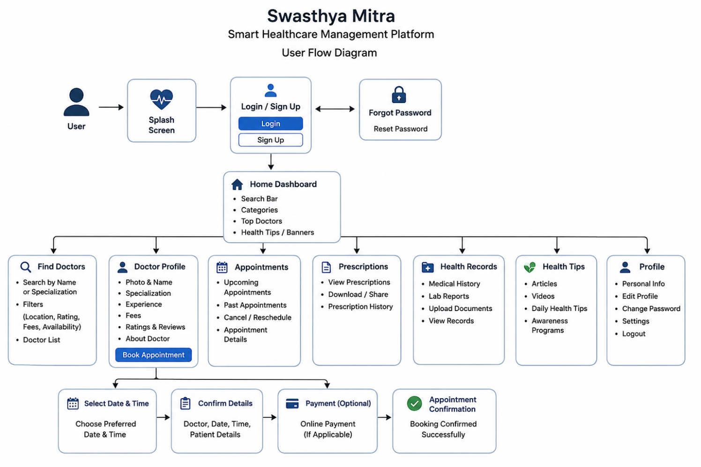

TECHNOLOGY STACK

The Swasthya Mitra: Smart Healthcare Management Platform is designed using modern UI/UX tools and resources to ensure visual clarity, accessibility, responsiveness, and a user-friendly healthcare experience. The selected tools provide a strong foundation for creating a clean and organized interface focused on doctor discovery, healthcare information, and appointment booking.
Design Tool
The primary design and prototyping are done using Figma.
- Figma is used for wireframing, high-fidelity UI design, and interactive prototyping.
- It supports component libraries, Auto Layout, and design systems to maintain consistency across all screens.
- Real-time collaboration allows easy review, feedback, and improvements during the design process.
- Cloud-based access ensures that the project can be accessed from different devices without additional installation.
Design Resources
The following resources are used during the design process:
- Google Fonts: Used for clear, readable, and professional typography.
- Icon Libraries: Figma plugins and icon libraries such as Material Icons and Feather Icons are used to create clear visual elements.
- Open-Source Images: Healthcare-related images and illustrations from free resources are used to improve visual engagement.
- Color Tools: Figma plugins and color-palette tools are used to create accessible, consistent, and visually balanced healthcare color schemes.
Prototyping Features
Interactive Linking: Used to connect screens and demonstrate the flow:
Home → Doctor Search → Doctor Profile → Appointment Booking
Smart Animate: Used to create smooth transitions between frames and simulate realistic platform interactions.
Device Frames: Used to preview and test responsive layouts across mobile and desktop screen sizes.
These technologies help create a responsive, accessible, and interactive healthcare prototype that simplifies doctor discovery, improves appointment booking, and provides a better digital healthcare experience.

IMPLEMENTATION

The implementation phase of the Swasthya Mitra: Smart Healthcare Management Platform focuses on converting the proposed system design into a fully interactive Figma prototype. This phase includes the creation of core healthcare screens, organization of reusable design components, linking of user flows, and visual refinement across multiple devices.
The project is designed as a responsive and modern healthcare UI concept with clean, professional, and user-friendly visual elements. It includes screens for doctor discovery, doctor profiles, healthcare information, appointment booking, and user management. The system supports doctor search, filtering, organized healthcare information, and intuitive navigation through clickable prototypes.
7A. Module Description
The Swasthya Mitra: Smart Healthcare Management Platform is divided into several functional modules to ensure proper organization, visual consistency, and easy navigation.
Home Screen Module
The Home Screen is the entry point of the platform and provides users with a clear overview of the available healthcare services.
Main Features of the Home Screen Module
- Hero banner with a healthcare-focused tagline
- Doctor search section for quick access to healthcare professionals
- Healthcare service categories for easy navigation
- Simple navigation bar for accessing important pages
- Consistent color scheme and typography across all elements
Design Enhancements
- Card-based layouts for clear content organization
- Healthcare-related visuals and icons to improve user engagement
- Clear visual hierarchy to guide users toward important features
Doctor Search Module
The Doctor Search Module allows users to find suitable healthcare professionals based on their requirements.
Main Features of the Doctor Search Module
- Search doctors by name, specialization, or location
- Filter options based on specialization, availability, consultation fees, and ratings
- Doctor cards displaying profile images, names, specializations, and ratings
- Clear navigation to detailed doctor profiles
Design Enhancements
Uniform doctor-card layouts for visual consistency
Organized filtering options to reduce user effort
Easy-to-scan interface for quick doctor discovery
Doctor Profile Module
The Doctor Profile Module provides detailed information about a selected healthcare professional.
Main Features of the Doctor Profile Module
- Doctor profile image and professional details
- Qualifications, specialization, and experience
- Consultation fees and patient ratings
- Available appointment slots
- Appointment booking option
Design Enhancements
- Clear visual hierarchy using headings and structured sections
- Readable typography and appropriate contrast for accessibility
- Organized information layout for easy understanding
Appointment Booking Module
The Appointment Booking Module enables users to select a suitable consultation date and time.
Main Features of the Appointment Booking Module
Date selection for appointments
Available time-slot selection
Appointment confirmation screen
Clear booking details before confirmation
Design Enhancements
Simple step-by-step booking flow
Clearly visible action buttons
Minimal input requirements to reduce user effort
Navigation and Prototyping Module
This module ensures smooth movement between screens in the Figma prototype.
Main Features of the Navigation Module
- Clickable buttons and doctor cards linking to relevant screens
- Back buttons on internal pages
- Interactive prototype flow:
Home → Doctor Search → Doctor Profile → Appointment Booking → Confirmation
- Smart Animate transitions for smooth screen changes
Purpose of Modular Design
The purpose of dividing the platform into modules is to maintain visual consistency, reduce interface complexity, improve user flow, and make the prototype easy to demonstrate, test, and evaluate.

7B. Screenshots

Splash screen(Desktop)



Splash screen(Mobile)
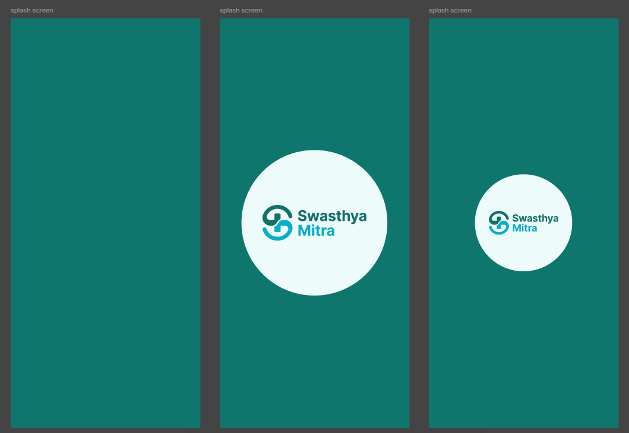

Sign in page(Desktop)
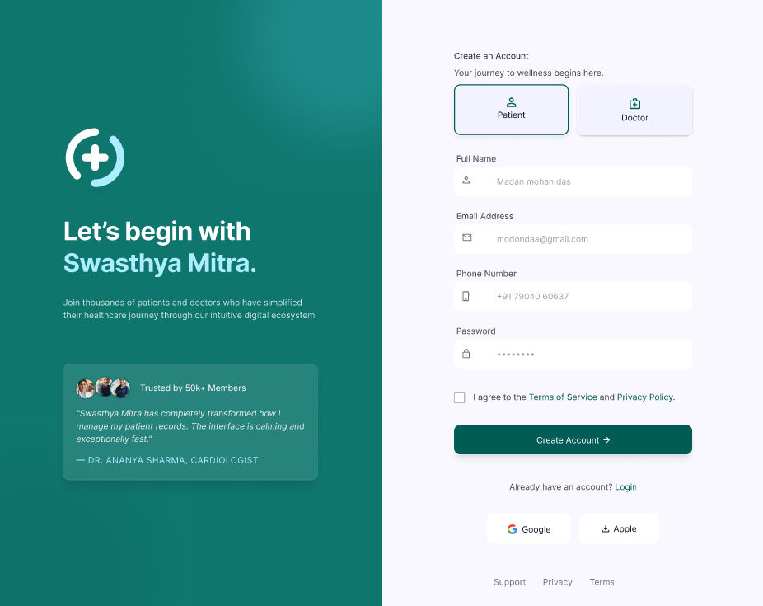

Sign in page(Mobile)

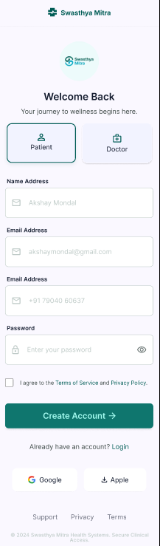

INCOMPLETE SIGN IN PGAE(Desktop)

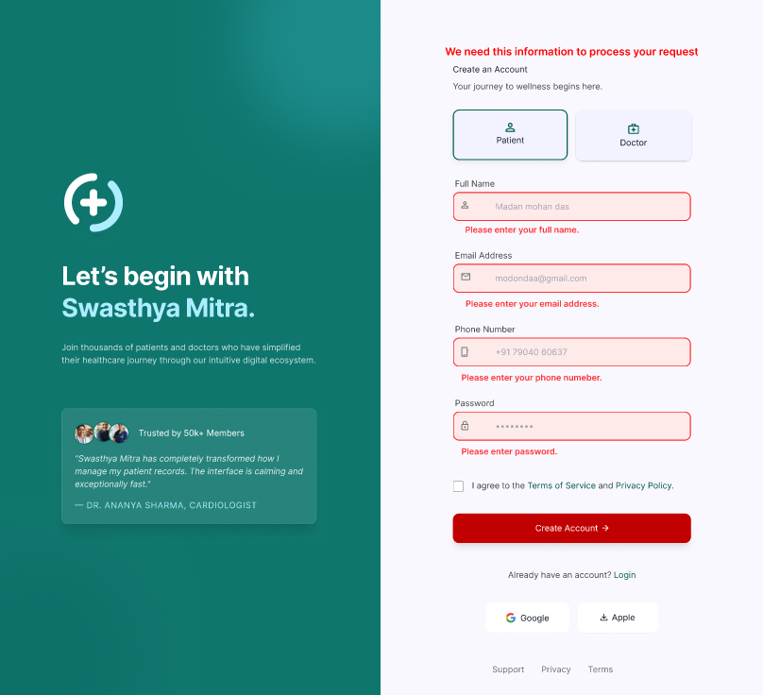

INCOMPLETE SIGN IN PGAE(Mobile)

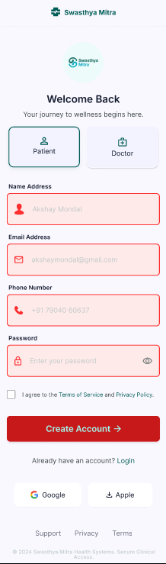
Login page(Desktop)

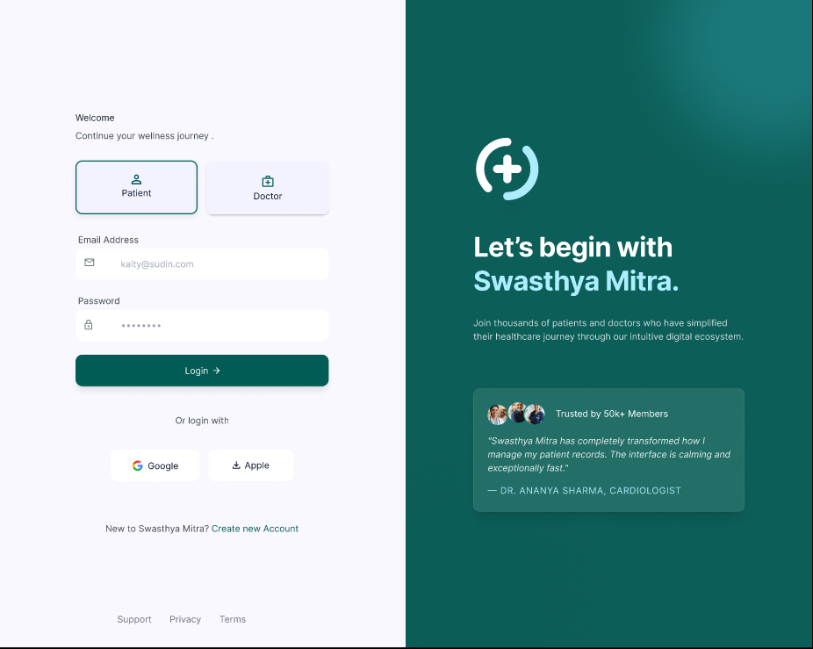

Login page(Mobile)

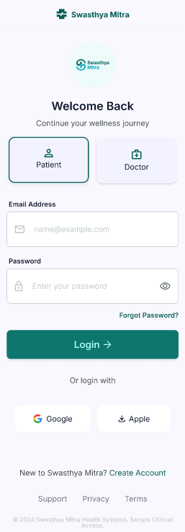
Incompleate Login page (Desktop)
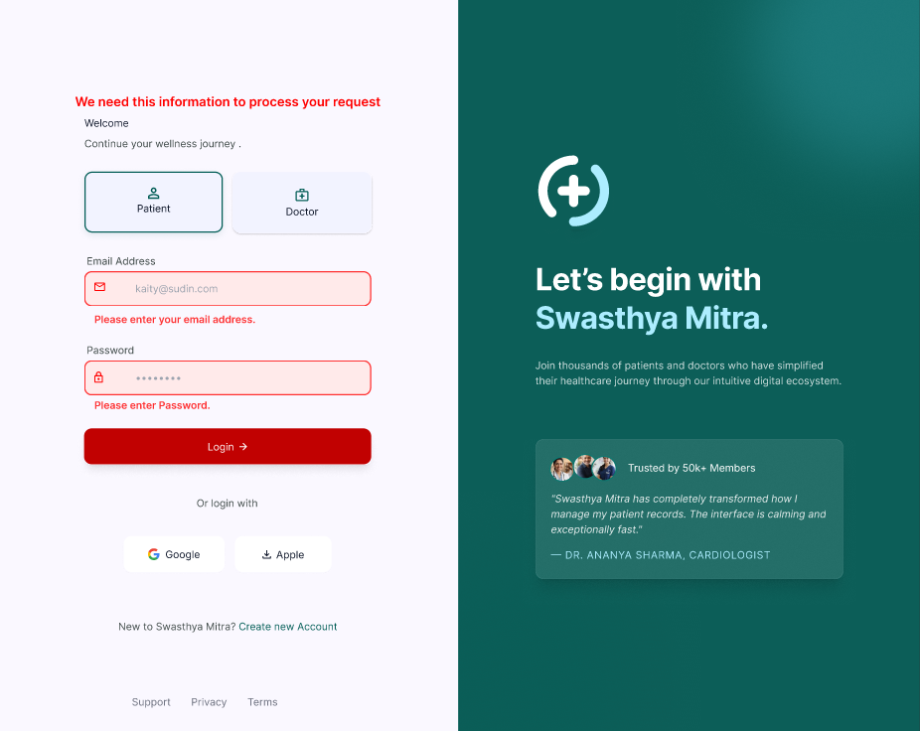

Incompleate Login page (Mobile)

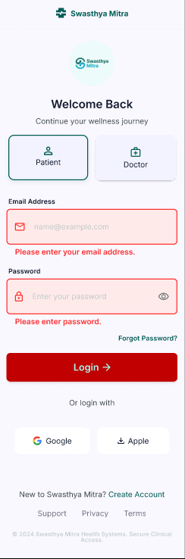

Home Page(Desktop)
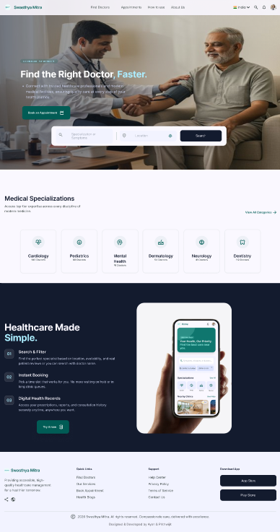

Home page (Mobile)

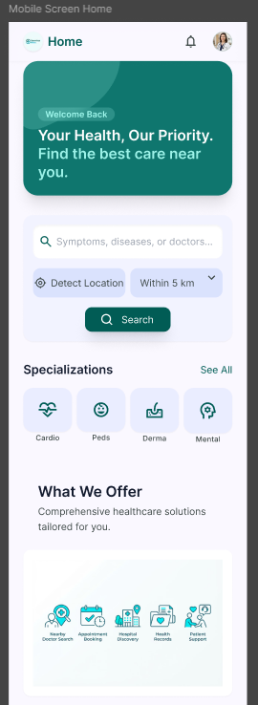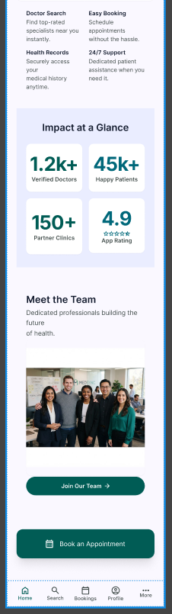

About page (only Desktop)

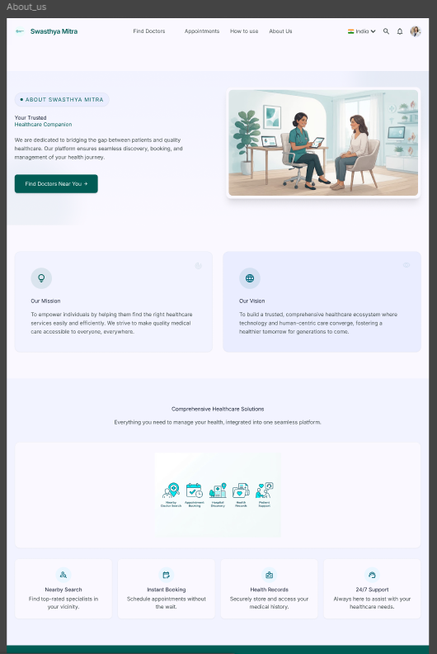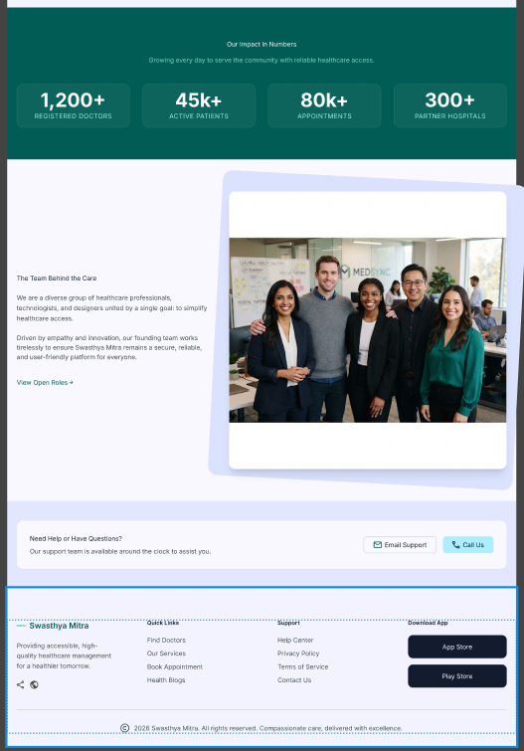

Search Doctor(Desktop)
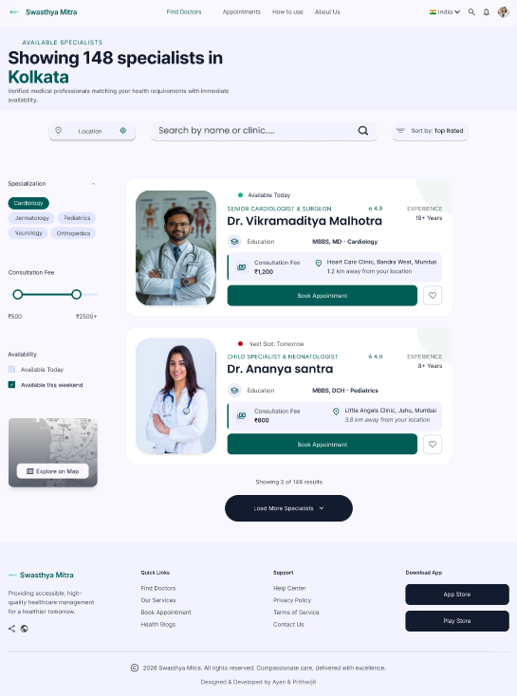

Doctor Profile And Book Appointment(Desktop)
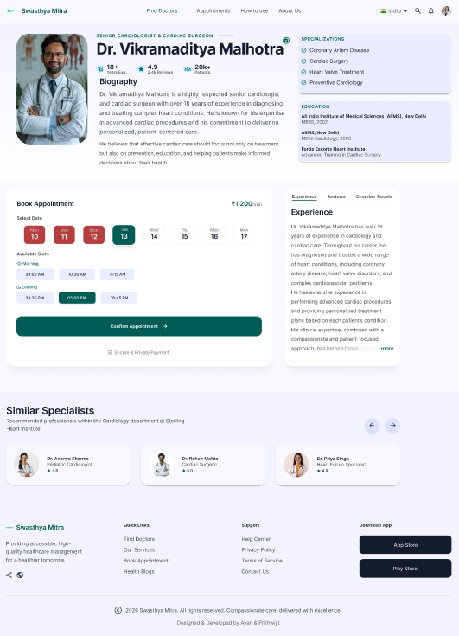

Doctor Profile And Book Appointment(Mobile)

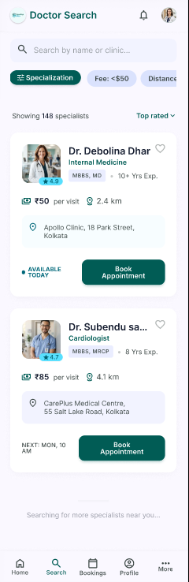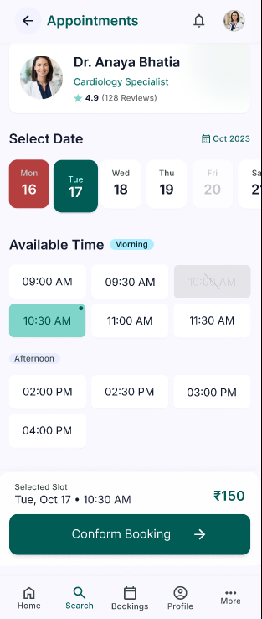

Pasent Dashboard(Desktop)
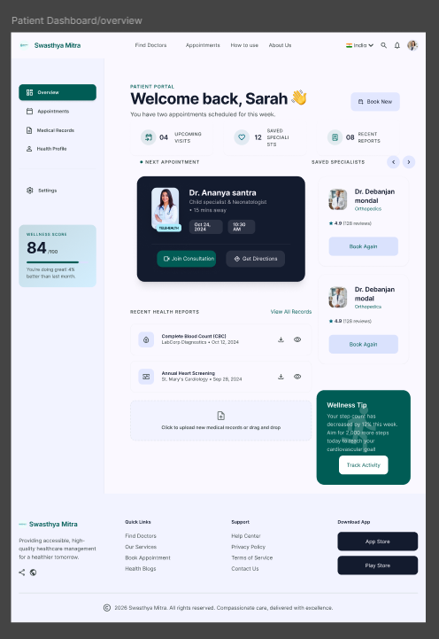

Pasent Dashboard(Mobile)

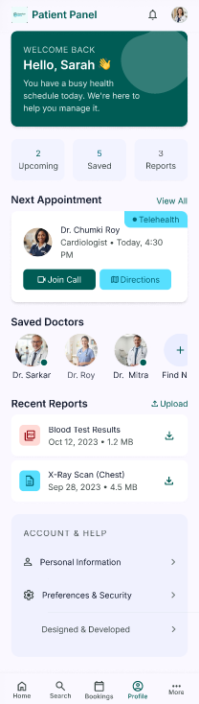

Appointments(Desktop)

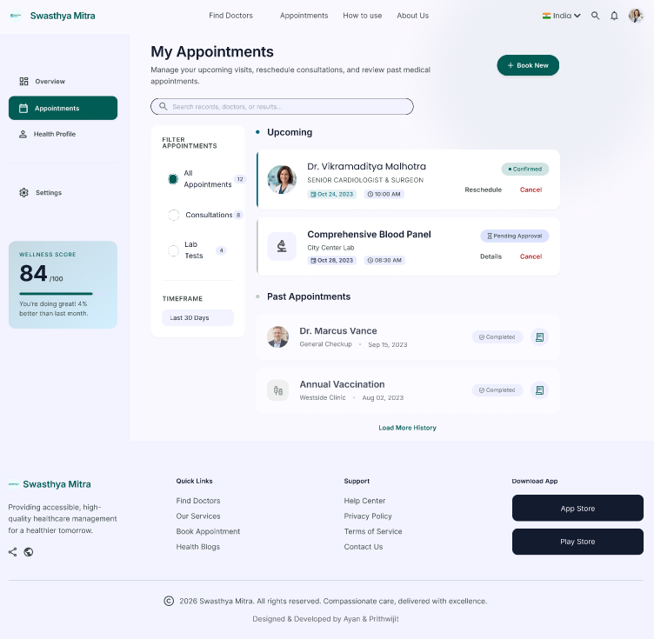

Appointments(Mobile)

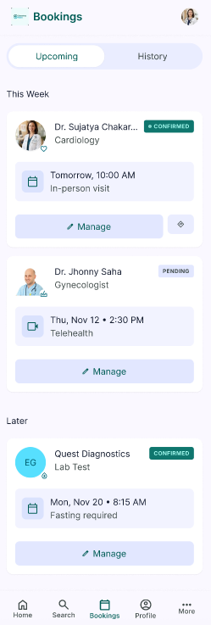

Pasent Details(Desktop)
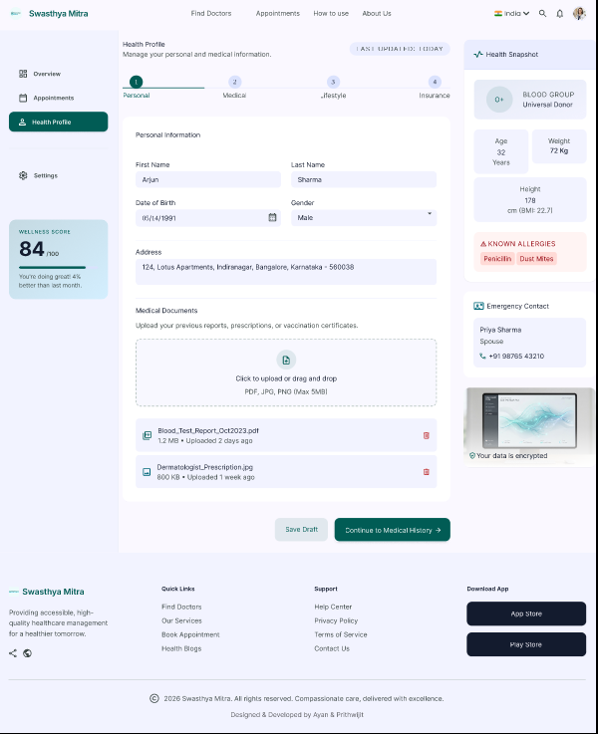

Pasent Details(Mobile)

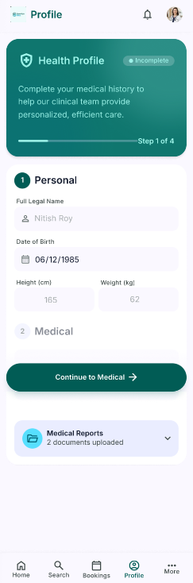

Developer(desktop)
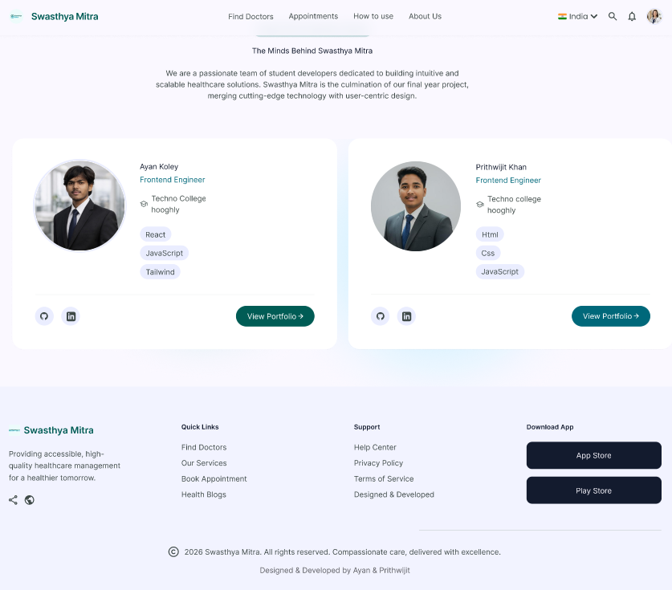

Developer(desktop)

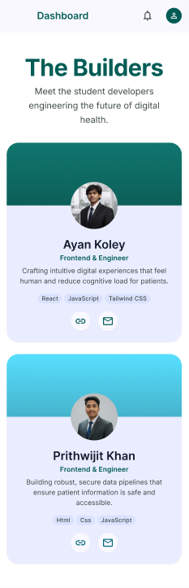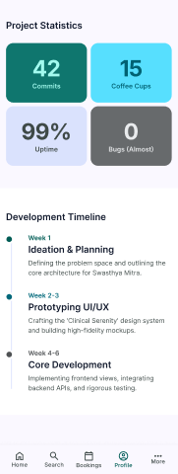

TESTING

Testing is one of the most important phases in UI/UX design. It ensures that the system is easy to use, visually consistent, and functions correctly across different devices. In the Swasthya Mitra: Smart Healthcare Management Platform, testing is carried out to verify the proper working of all design modules, such as Home Screen navigation, Doctor Search, Doctor Profile views, appointment booking, and interactive prototype flows.
The testing process helps identify usability issues, validate design consistency, and improve the overall healthcare experience. Both Usability Testing and Design Consistency Testing are used to ensure that individual screens and the complete Figma prototype provide a smooth, clear, and user-friendly experience for patients and healthcare professionals.

Test Cases Table
The following table shows some important test cases performed on the Swasthya Mitra: Smart Healthcare Management Platform.

Test Case ID | Test Case | User Action | Expected Output | Result
TC01 | Home Screen Load | Open prototype link | Home screen displays healthcare services and navigation clearly | Pass
TC02 | Doctor Search | Search for a doctor by name or specialization | Relevant doctor results are displayed | Pass
TC03 | View Doctor Profile | Click on a doctor card | Doctor profile displays qualifications, experience, specialization, and ratings | Pass
TC04 | Doctor Filter | Select a specialization or location filter | Doctor list updates according to the selected filter | Pass
TC05 | Check Doctor Availability | Open a doctor profile | Available consultation dates and time slots are displayed | Pass
TC06 | Appointment Booking | Select a date and available time slot | Appointment details are displayed for confirmation | Pass
TC07 | Appointment Confirmation | Click the “Confirm Appointment” button | Appointment confirmation screen is displayed | Pass
TC08 | Back Navigation | Click the back button from the Doctor Profile | User returns to the previous doctor listing screen | Pass
TC09 | Mobile Responsive Check | Open the prototype on a mobile frame | Layout adapts correctly, text remains readable, and no overflow occurs | Pass
TC10 | Tablet Responsive Check | Open prototype on 768px frame | Grid adjusts to 2-3 columns, images scale | Pass
TC11 | Desktop Responsive Check | Open the prototype on a desktop frame | Full-width layout displays correctly with properly aligned elements | Pass
TC12 | Prototype Link Functionality | Click all interactive buttons and doctor cards | Each element links to the correct screen | Pass
TC13 | Transition Animation | Navigate between different screens | Smooth transitions are displayed between screens | Pass
TC14 | Font Readability | Check text across different screen | Text is clear, readable, and maintains sufficient contrast | Pass
TC15 | Design Consistency | Compare colors, buttons, icons, and cards across screens | All UI elements maintain a consistent style and appearance | Pass

8A. Unit Testing
Unit Testing in UI/UX is performed to test individual design components or screens separately. Each element is checked independently to confirm that it performs its intended visual and interactive function correctly.
Examples of Unit Testing in this Project
- Testing doctor cards for correct images, names, specializations, and ratings
- Testing buttons for proper size, color, and clickable area
- Testing the navigation bar for icon clarity and alignment
- Testing search and filter components for proper layout and usability
- Testing appointment date and time-slot components
- Testing text color and background contrast
Advantages of Unit Testing
- Helps identify design inconsistencies at an early stage
- Improves visual consistency across screens
- Makes design updates and iterations easier
- Ensures that each component works correctly before integration
In this project, Unit Testing is mainly used for Figma components, design styles, Auto Layout frames, and interactive states.
8B. Integration Testing
Integration Testing is used to verify whether different screens and components work together properly after linking. It ensures a smooth navigation flow between the Home, Doctor Search, Doctor Profile, and Appointment Booking modules.
Examples of Integration Testing in this Project
- Checking whether the doctor search option opens the correct doctor listing screen
- Verifying that clicking a doctor card opens the correct doctor profile
- Testing whether the appointment button opens the booking screen
- Confirming that the back button returns users to the correct previous screen
- Ensuring smooth transitions between Home → Doctor Search → Doctor Profile → Appointment Booking
- Verifying that navigation elements remain consistent across all screens
Advantages of Integration Testing
- Detects broken links and navigation errors
- Validates the complete user journey
- Ensures that screens and components work together correctly
- Improves the overall reliability of the prototype
Integration Testing is important because the Swasthya Mitra platform consists of multiple connected screens and interactive healthcare-related user flows.
8C. Functional Testing
Functional Testing is performed to check whether the prototype features work according to the design requirements.
Functional Areas Tested
- Doctor search functionality
- Doctor specialization and location filtering
- Doctor-card navigation
- Doctor profile viewing
- Appointment date and time-slot selection
- Appointment confirmation flow
- Back-button functionality
- Screen transitions and animations
- Content organization and readability
- Button and icon interactions
This testing confirms that the prototype behaves correctly from the user’s perspective.
8D. User Interface Testing
User Interface Testing is used to verify the visual design, consistency, accessibility, and usability of the healthcare platform.
Key Areas Tested
- Responsive layouts on mobile, tablet, and desktop frames
- Button alignment and spacing consistency
- Doctor-card visibility and image quality
- Navigation menu placement and usability
- Typography hierarchy and font sizes
- Healthcare color scheme and text contrast
- Form-field clarity and appointment-screen organization
- Animated transitions and interactive effects
This testing ensures that the platform is user-friendly, professional, visually consistent, and easy to navigate.
8E. Performance Testing
Performance Testing checks whether the Figma prototype performs efficiently during user interaction.
Performance Aspects Tested
- Fast loading of the Figma prototype link
- Quick and smooth screen transitions
- Proper rendering of doctor cards and healthcare visuals
- Smooth scrolling on long doctor-profile screens
- Quick response when switching between device frames
- No noticeable delay during interactive navigation
This testing helps ensure that the prototype can be demonstrated smoothly during project presentations and user evaluations.
8F. Testing Summary
The testing results show that the Swasthya Mitra: Smart Healthcare Management Platform performs effectively across its major modules. Doctor search, doctor-profile viewing, appointment booking, navigation, interactive flows, and responsive layouts function correctly according to the expected results.
The use of Unit Testing, Integration Testing, Functional Testing, User Interface Testing, and Performance Testing helps improve design quality, reduce usability issues, and ensure that the prototype is reliable for academic presentation. Therefore, the testing phase confirms that the platform is user-friendly, visually consistent, and ready for demonstration and future enhancement.

RESULTS & DISCUSSION

The Swasthya Mitra: Smart Healthcare Management Platform has been successfully designed and prototyped using Figma, focusing on doctor discovery, healthcare information, doctor profiles, and appointment booking.
The system provides a clean, responsive, and user-friendly interface with intuitive navigation and a professional visual design to improve the overall digital healthcare experience.
9A. Output Screenshots
This section presents the output of different modules of the design through screenshots. These outputs demonstrate the working prototype, UI/UX design, interactive features, and visual consistency of the platform.
Home Screen Output
- Hero section with a healthcare-focused tagline and visual banner
- Doctor search section for quick access to healthcare professionals
- Healthcare service cards and organized navigation
- Clean navigation bar with a modern layout
Output:
- Users can access important healthcare services from a single screen
- Clear navigation helps users easily begin their healthcare journey
Doctor Search Output
- Search and filtering options for finding suitable doctors
- Doctor cards displaying profile images, names, specializations, and ratings
- Organized layout with consistent card sizes and spacing
Output:
- Users can search and compare doctors easily
- Clear information and visual hierarchy help users make suitable choices
Doctor Profile Output
- Doctor profile image and professional information
- Qualifications, specialization, experience, ratings, and consultation details
- Doctor availability and appointment-booking option
Output:
- Users can view detailed information before selecting a doctor
- Organized profile sections improve clarity and decision-making
Appointment Booking Output
- Date and available time-slot selection
- Clear appointment details and booking information
- Appointment confirmation screen
Output:
- Users can book appointments through a simple and organized process
- The step-by-step flow reduces user effort and confusion
Navigation Flow Output
- Clickable prototype links: Home → Doctor Search → Doctor Profile → Appointment Booking
- Smooth transitions between screens
- Back buttons on internal pages
Output:
- Users can complete the healthcare journey without confusion
- Interactive transitions improve the realism and usability of the prototype
Responsive Layout Output
- Mobile layout with organized healthcare cards
- Tablet layout with responsive content arrangement
- Desktop layout with a full-width interface
Output:
- The design adapts properly to different screen sizes
- Text, buttons, images, and healthcare information remain clear and accessible

9B. Performance Analysis
The performance of the Swasthya Mitra: Smart Healthcare Management Platform prototype has been evaluated based on usability, responsiveness, visual consistency, and interaction efficiency.
Response Time
- Prototype link loads quickly in Figma
- Screen transitions are smooth using Smart Animate
- Doctor cards, healthcare images, and UI elements load without noticeable delay
Usability
- Figma Auto Layout ensures consistent spacing and alignment
- Reusable components allow quick design updates across multiple screens
- Interactive prototypes support the complete healthcare user journey
- Clear navigation reduces the effort required to find doctors and book appointments
Efficiency
- Doctor search and filtering reduce the time required to find suitable healthcare professionals
- Organized doctor profiles improve access to important information
- A clean and structured interface minimizes user confusion and cognitive load
- Simple appointment flows improve the overall healthcare experience
Responsiveness
- The responsive design is tested on:
- Mobile: iPhone 14 frame
- Tablet: iPad frame
- Desktop: 1440px frame
Design Performance
- Color contrast is maintained for clear readability
- Font sizes remain readable across different devices
- Buttons and interactive elements are clearly visible and easy to access
- Consistent colors, typography, spacing, and components are maintained throughout the platform

9C. Observations
During the design and testing of the Swasthya Mitra: Smart Healthcare Management Platform, several important observations were made:
System Functionality
- All prototype links work correctly as expected
- Smooth navigation between Home, Doctor Search, Doctor Profile, and Appointment Booking screens
- Interactive user flow is stable with no broken links
User Experience
- Clean and professional UI improves user trust and visual appeal
- Easy navigation supports first-time users
- Organized doctor information improves doctor discovery and decision-making
Design Performance
- Doctor cards improve the readability and comparison of healthcare professionals
- Structured layouts make healthcare information easy to scan
- Consistent components maintain visual uniformity throughout the platform
Limitations
- The prototype does not include live doctor search or real-time appointment booking
- Doctor information and availability are static and not connected to a database
- No real payment, video consultation, or patient-record functionality is included
- Interactions are limited to the capabilities of the Figma prototype
Future Improvements
- Add AI-based doctor recommendations and advanced search filters
- Integrate real-time doctor availability and appointment scheduling
- Include online video consultation features
- Add digital health records and medicine reminders
- Include patient reviews, ratings, and feedback features
- Provide multilingual support for wider accessibility

9D. Conclusion of Results
The developed Swasthya Mitra: Smart Healthcare Management Platform meets the major project requirements and demonstrates effective performance in terms of usability, visual design, accessibility, and navigation flow.
The use of organized doctor information, structured healthcare layouts, and simple appointment-booking flows improves the user experience and makes healthcare services easier to access. The interactive prototype successfully validates the proposed design concept and is ready for academic presentation and future development.

CONCLUSION
.

The Swasthya Mitra: Smart Healthcare Management Platform has been successfully designed and prototyped using Figma, with a focus on simplifying doctor discovery, improving access to healthcare information, and streamlining appointment booking.
The project demonstrates how thoughtful UI/UX design can improve the healthcare experience by providing organized doctor profiles, clear search and filtering options, intuitive navigation, and a simple appointment-booking process. Through responsive layouts, consistent design components, and smooth interactive flows, the prototype ensures accessibility across mobile, tablet, and desktop devices.
Usability testing confirms that users can easily search for doctors, view professional details, check availability, and navigate the platform without confusion. The design successfully meets the objectives of reducing user effort, improving accessibility, and creating a clean, professional, and user-friendly digital healthcare experience.
In conclusion, the prototype validates the effectiveness of a user-centered approach to healthcare platform design. It establishes a strong foundation that can be extended with additional features such as online video consultations, real-time appointment scheduling, digital health records, AI-based doctor recommendations, medicine reminders, and secure online payments in future development phases.

10A. What We Achieved
Through this project, the following objectives have been successfully accomplished:
- Designed a complete UI/UX prototype using Figma for healthcare management
- Implemented doctor search and filtering based on specialization, location, availability, fees, and ratings
- Created a responsive design system with reusable components and consistent styles
- Built intuitive user flows from Home → Doctor Search → Doctor Profile → Appointment Booking
- Developed responsive layouts for mobile, tablet, and desktop devices
- Ensured visual consistency through unified colors, typography, icons, and spacing
- Applied interactive transitions to create smooth screen navigation
- Conducted usability testing to evaluate design effectiveness
- Maintained accessibility through readable text, proper color contrast, and clear interactive elements
- Created a clean and professional interface for easy access to healthcare services
10B. Summary of the System
The Swasthya Mitra: Smart Healthcare Management Platform is a complete UI/UX prototype that simplifies access to healthcare services through organized doctor information, intuitive navigation, and an easy appointment-booking process.
For Patients
- Search for doctors based on specialization, location, and other preferences
- View detailed doctor profiles, qualifications, experience, and ratings
- Check doctor availability and consultation details
- Select suitable appointment dates and time slots
- Navigate smoothly through clear buttons and consistent layouts
For Academic Evaluation
- Demonstrates the practical application of UI/UX design principles
- Showcases responsive design across multiple device screens
- Validates the component-based design approach in Figma
- Demonstrates effective healthcare information organization and user flows
For Future Development
- Provides a strong design foundation for a real healthcare website or mobile application
- Establishes a visual style guide and reusable component library
- Defines clear user journeys for future developer handoff
10C. Overall Outcome
The system successfully meets the major functional and design requirements of a modern healthcare management platform. The integration of doctor discovery, organized doctor profiles, and appointment-booking features improves access to healthcare services and reduces user effort.
The prototype is visually consistent, accessible, user-friendly, and ready for academic presentation. The project demonstrates practical implementation of:
- UI/UX Design Process: User research, wireframing, prototyping, testing, and iteration
- Figma Proficiency: Components, Auto Layout, design styles, constraints, and interactive prototyping
- Responsive Design: Mobile, tablet, and desktop layouts
- Visual Design: Healthcare-focused colors, typography, icons, spacing, and visual hierarchy
- User-Centered Design: Usability testing and improvements based on user feedback
10D. Final Statement
In conclusion, Swasthya Mitra: Smart Healthcare Management Platform is a well-designed and practical solution that improves the traditional healthcare access experience through organized doctor information, intuitive navigation, simplified appointment booking, and user-centered UI/UX design.
The platform provides a strong foundation for future enhancements and real-world application development, including online consultations, digital health records, AI-based doctor recommendations, real-time appointment management, and secure healthcare services.

FUTURE SCOPE

The Swasthya Mitra: Smart Healthcare Management Platform developed in this project provides a strong foundation for improving digital healthcare access. However, there are several opportunities to further enhance the system by integrating advanced healthcare features, improving accessibility, and expanding platform functionality for better user experience and scalability.
11A. Improvements
The current prototype can be improved in the following ways to make it more advanced and industry-ready:
Advanced Doctor Search & Filters
- Implement keyword search for doctors and healthcare services
- Add filters based on specialization, location, consultation fees, availability, and ratings
- Include sorting options based on experience, patient ratings, consultation fees, or distance
Enhanced Healthcare Experience
- Add detailed healthcare service information
- Include doctor introduction videos and professional highlights
- Provide personalized doctor recommendations based on user requirements
Performance Optimization
- Optimize healthcare images and visual assets for faster loading
- Use Figma variables for light and dark mode design themes
- Improve screen transitions and loading performance during final development
Interactive Features
- Add favorite or bookmark options for doctors
- Enable appointment reminders and notifications
- Include patient reviews and feedback features
- Add secure sharing of doctor and appointment information
Accessibility Features
- Add voice navigation support
- Implement text-to-speech for healthcare information
- Provide adjustable font sizes for improved readability
- Ensure WCAG 2.1 AA accessibility standards for color contrast and interactive elements
11B. Advanced Feature Integration
The system currently focuses on doctor discovery and appointment booking, but it can be enhanced further by integrating advanced healthcare features:
Online Consultation Integration
- Enable secure video and audio consultations with doctors
- Allow patients to schedule and join virtual appointments
- Provide in-app chat for basic communication and follow-up
Digital Health Records
- Allow users to securely store medical reports and prescriptions
- Provide access to previous consultations and treatment history
- Enable doctors to review relevant patient information with permission
AI-Based Doctor Recommendations
- Suggest suitable doctors based on symptoms and healthcare needs
- Recommend specialists based on user preferences and medical requirements
- Provide personalized healthcare suggestions
Medicine Reminder System
- Send reminders for medicines and scheduled appointments
- Allow users to create daily medicine schedules
- Provide notifications for prescription refills
Real-Time Appointment Management
- Display live doctor availability and appointment slots
- Allow users to reschedule or cancel appointments
- Send instant appointment confirmations and notifications
Emergency Healthcare Support
- Provide quick access to emergency contact numbers
- Display nearby hospitals, clinics, and ambulance services
- Integrate location-based emergency assistance

11C. Mobile Application Version
To improve accessibility and user engagement, the Swasthya Mitra: Smart Healthcare Management Platform can be extended into a native mobile application:
Cross-Platform Mobile App
- Develop the application using React Native or Flutter based on the existing Figma design
- Make the application available for both Android and iOS devices
Mobile-Specific Features
- Push notifications for appointment reminders and healthcare updates
- GPS-based “Doctors Near Me” and nearby hospital services
- Camera integration for uploading medical reports and prescriptions
- Secure offline access to selected health information and appointment details
Enhanced User Experience
- Touch-friendly interactions for easy navigation
- Faster access through a bottom navigation bar
- Personalized home screen based on healthcare preferences
- Quick access to upcoming appointments and saved doctors
Patient Support Features
- Secure communication with doctors through chat or video consultation
- Upload and manage medical reports and prescriptions
- Receive medicine reminders and healthcare notifications
- Access emergency contacts and nearby healthcare services

---

11D. Cloud & Deployment Enhancements
- Deploy as a Progressive Web App (PWA)
- Allow users to install the healthcare platform on their mobile home screen
- Provide offline access to selected healthcare information and appointment details
- Use a Secure Backend and Database
- Use services such as Firebase, Supabase, or a secure cloud database to manage user accounts, doctor profiles, appointments, and healthcare information
- Allow real-time updates without changing the application code
- Cloud Storage for Medical Documents
- Securely store medical reports, prescriptions, and healthcare documents
- Allow authorized users to access and manage their healthcare information
- Implement CDN for Images and Assets
- Use Cloudinary or ImageKit for faster delivery of healthcare images and visual assets
- Automatically optimize images for different devices and screen sizes
- Analytics Integration
- Use analytics tools to understand doctor searches, appointment activity, and user navigation
- Analyze user interactions to identify areas for improving usability and platform performance
- Security and Privacy Enhancements
- Implement secure user authentication and encrypted data storage
- Protect patient information and maintain healthcare data privacy
- Add role-based access for patients, doctors, and administrators

11E. Future Expansion
- Multi-language Support
- Provide Bengali, Hindi, English, and other regional language options
- Add voice assistance and healthcare information in local languages
- Healthcare Service Integration
- Integrate online consultation and appointment services
- Add diagnostic test and healthcare service booking
- Enable secure online payment for consultations
- Community and Patient Support Features
- Allow patients to provide doctor ratings and reviews
- Add healthcare awareness articles and educational content
- Include a secure question-and-answer section for general healthcare guidance
- Hospital and Healthcare Partnerships
- Integrate verified hospitals, clinics, and healthcare professionals
- Provide verified badges for registered doctors and healthcare organizations
- Enable direct appointment booking with partner healthcare providers
- Personalized Healthcare Features
- Provide personalized doctor recommendations
- Add medicine reminders and health-tracking tools
- Offer preventive healthcare tips based on user preferences
- Emergency Healthcare Support
- Provide quick access to emergency contact numbers
- Show nearby hospitals, clinics, pharmacies, and ambulance services
- Enable location-based emergency assistance

REFERENCES

The following references were used during the development and documentation of the UI/UX Design for the Swasthya Mitra: Smart Healthcare Management Platform. These include books, research papers, and online resources that helped in understanding UI/UX principles, healthcare system design, usability, accessibility, and interactive prototyping.

Books
S. Krug, Don’t Make Me Think, Revisited: A Common Sense Approach to Web Usability, 3rd ed. Berkeley, CA: New Riders, 2014. [1]
J. Nielsen, Usability Engineering. San Francisco, CA: Morgan Kaufmann, 1993. [2]
A. Cooper, R. Reimann, D. Cronin, and C. Noessel, About Face: The Essentials of Interaction Design, 4th ed. Indianapolis, IN: Wiley, 2014. [3]
D. Norman, The Design of Everyday Things: Revised and Expanded Edition. New York, NY: Basic Books, 2013. [4]
B. Arvola, Interaction Design: A Human-Centred Approach. Stockholm, Sweden: Liber, 2017. [5]

Research Papers
M. Hassenzahl and N. Tractinsky, “User Experience – A Research Agenda,” Behaviour & Information Technology, vol. 25, no. 2, pp. 91–97, 2006. [6]
A. Holzinger, “Usability Engineering Methods for Software Developers,” Communications of the ACM, vol. 48, no. 1, pp. 71–74, 2005. [7]
J. Zhang and D. Walji, “TURF: Toward a Unified Framework of EHR Usability,” Journal of Biomedical Informatics, vol. 44, no. 6, pp. 1056–1067, 2011. [8]
E. Ammenwerth, C. Iller, and C. Mahler, “IT-Adoption and the Interaction of Task, Technology, and Individuals,” BMC Medical Informatics and Decision Making, vol. 6, 2006. [9]

Websites
Figma Design and Prototyping Documentation [10]
Google Material Design Guidelines [11]
Apple Human Interface Guidelines [12]
Nielsen Norman Group – UX Research and Usability Articles [13]
World Health Organization – Digital Health Resources [14]
National Health Authority – Ayushman Bharat Digital Mission [15]
Practo – Doctor Consultation and Healthcare Services [16]
Tata 1mg – Digital Healthcare Platform [17]
Apollo 24|7 – Online Healthcare Services [18]
Google Fonts – Typography Resources [19]

